Julia See
BUMK746
Jacobs
Individual Assignment 3- Visualization
- Pick a chart that you have created before, or from another source:
- This chart was downloaded from Public Tableau Data
- The source is: https://public.tableau.com/app/profile/covid.19.data.resource.hub/viz/COVID-19Cases_15840488375320/COVID-19GlobalView
  - This was a Global COVID-19 Tracker (1/21/2020-4/29/2022)
  - This data was downloaded as an image; this data was the top right:
  - Data was the graph on the right with the title of:
    - New Positive Cases (Select a Country to see more details)
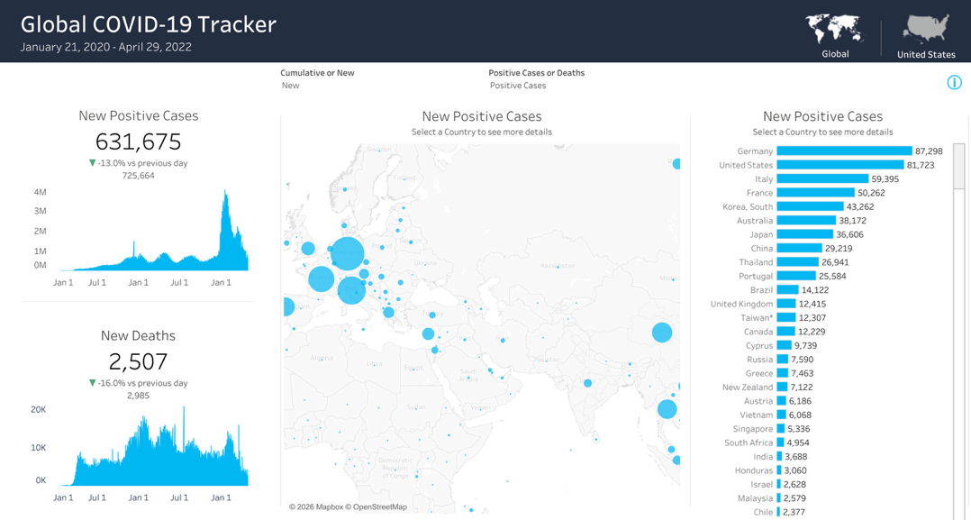
- I imported the data into R and redesigned the original chart as a treemap.
- UPDATED CHART:
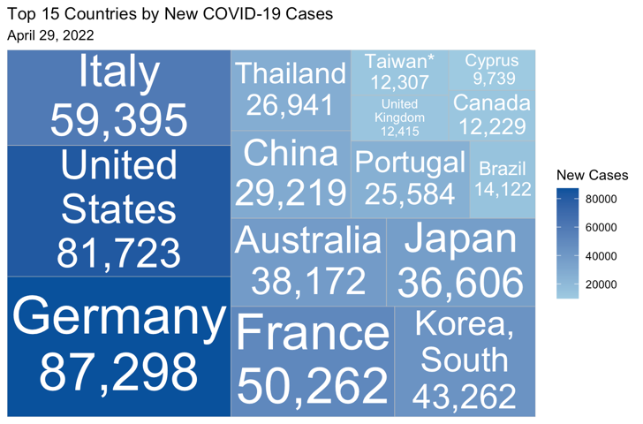
TITLE:
- IMPROVING COVID-19 CASE VISUALIZATION
ORIGINAL CHART:
- The original chart came from the Tableau Public dashboard “Global COVID-19 Tracker.” I used the right-side “New Positive Cases” view as the starting point.
UPDATED CHART:
- I redesigned the chart as a treemap showing the top 15 countries by new COVID-19 cases on April 29, 2022.
CHANGES MADE:
- Simplified the original dashboard into a single focused chart.
- Removed unrelated dashboard elements such as the map, KPI cards, and time-series panels.
- Limited the display to the top 15 countries to reduce clutter
- Used a treemap so area directly represents the relative size of new case counts.
- Added direct labels for both country names and values.
- Used a sequential blue color scale to reinforce differences in case magnitude.
- Improved the title and subtitle so the chart’s message and date are immediately clear.
WHY THE UPDATED CHART IS BETTER
- The updated chart is easier to read because it focuses on one message instead of several competing visuals.
- It makes the largest contributors stand out immediately, especially Germany, the United States, and Italy.
- Labeling countries and values directly inside each rectangle reduces the need to scan back and forth.
- The treemap highlights relative magnitude more clearly than the original crowded dashboard layout.
- Overall, the revised chart communicates the ranking and scale of new COVID-19 cases in a cleaner and more visually effective way.

